Parent Training Guide

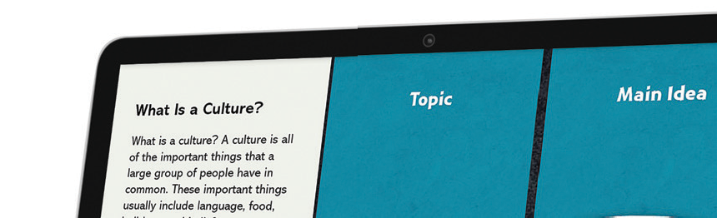What is i-Ready?
i-Ready is an interactive online learning environment designed to assess students and provide individualized instruction based on each one’s unique needs. The exciting format and engaging content, as well as the Study Buddies and other interesting contemporary characters draw students in right away.
onment designed to
nstruction based on
at and engaging content,
esting contemporary
The i-Ready experience builds students’ investment in their learning by giving them real-time feedback on their progress in
stment in their
on their progress in
each skill. As they complete each assignme t successfully, they
nt successfully, they
earn credits that they can use to play game . i-Ready also provides opportunities to learn both at school
s.
i-Ready
also
ol
and at home.

How can I help my child get the most out of
i-Ready?
- Talk with your child about how using i-Ready at home will help him/her prepare for class work. Also explain that i-Ready will show teachers where your child is doing well and which topics need some more review.
- Encourage your child to use the tools provided during lessons and to use scrap paper to work out
math problems.
- Help your child identify and become familiar with the different parts of the student home page (“My Assignments”, “My Stuff”, “My Progress”).
- To help your child get started, see “How Does My Child Navigate i-Ready“(p. 2).
- Have your child use the “Student Instructions to Completing Online Lessons” (p. 3).
- Encourage your child to take each lesson and question seriously. Emphasize “thinking before
clicking”, because just clicking through will not give teachers an accurate report of what
your child knows and is able to do.
- Discuss your child’s results by looking at the “My Progress” box with him/her.
- Contact your child’s teacher about how often your child should practice at home,
or with any other questions about i-Ready.

Where can I go to see how my child is performing?
- Log in with your child’s Username and Password.
- View your child’s “My Progress” box.
- Click on “Detail” to see your child’s progress by each skill domain and standard.

For more information on i-Ready, go to www.i-Ready.com/Tour

  - OF 3
©2015 Curriculum Associates, LLC

How does i-Ready work with what my child is learning in the classroom?
i-Ready is designed to complement what is being taught in the classroom. The lessons are assigned based on how your child performed in the Diagnostic test, which he/she must complete before starting work on the lessons.
The lessons are presented in three parts: tutorial, guided practice, and graded activity. Your child will get relevant instruction with supportive feedback as he/she progresses through the lessons.

How does my child navigate i-Ready?

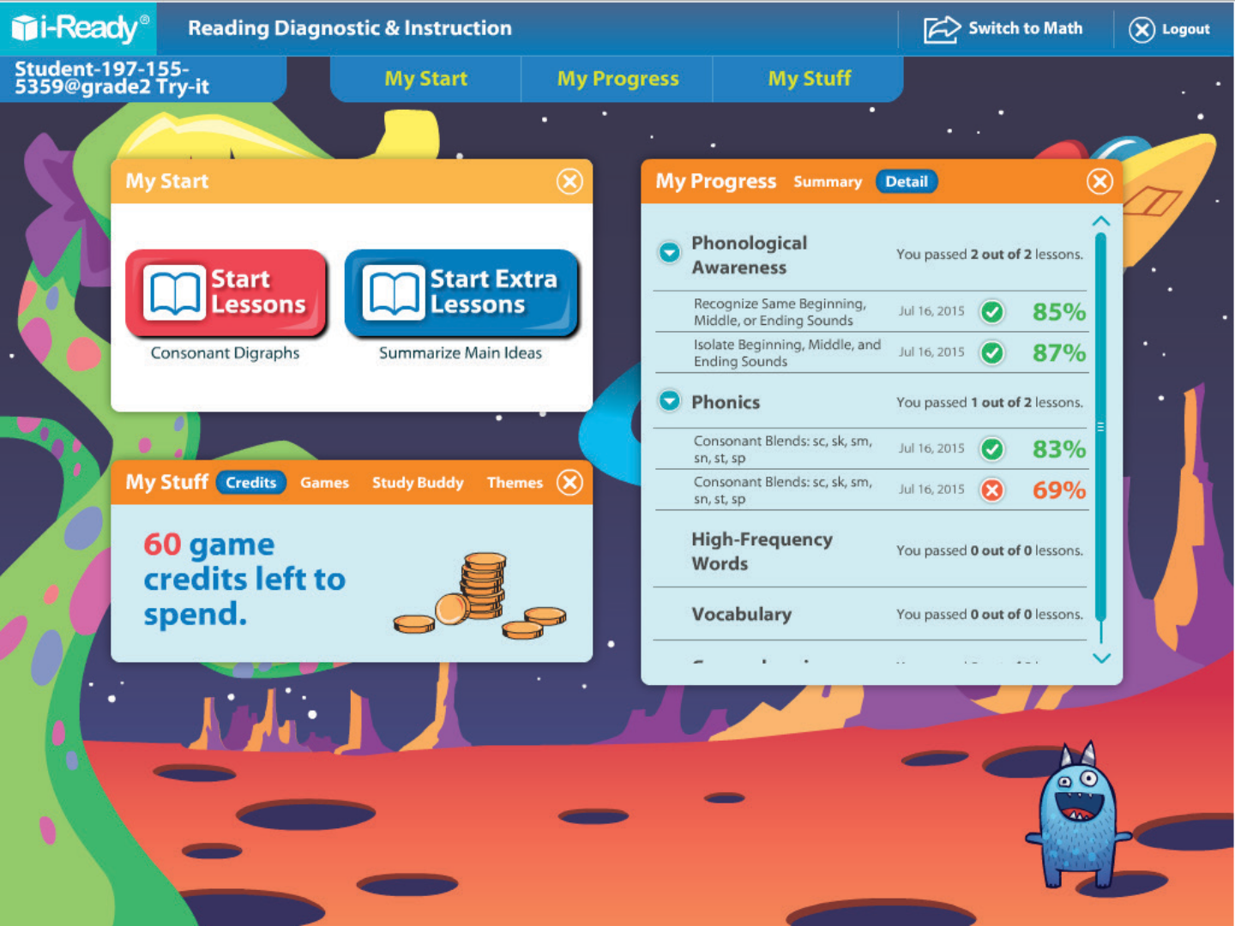Clicking on Summary shows the number of lessons passed and game credits earned.
Clicking on Detail will show student progress on each domain and standard.

Students will be prompted to go to next lesson assigned to them.
Students can choose background themes, choose Study Buddies, and play games with credits earned!

  - OF 3
©2015 Curriculum Associates, LLC

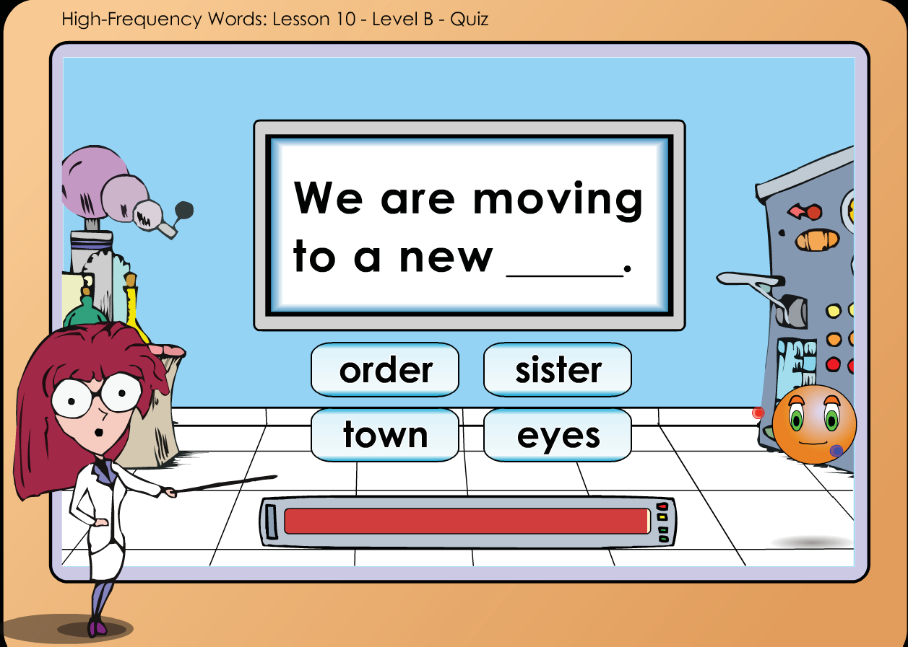
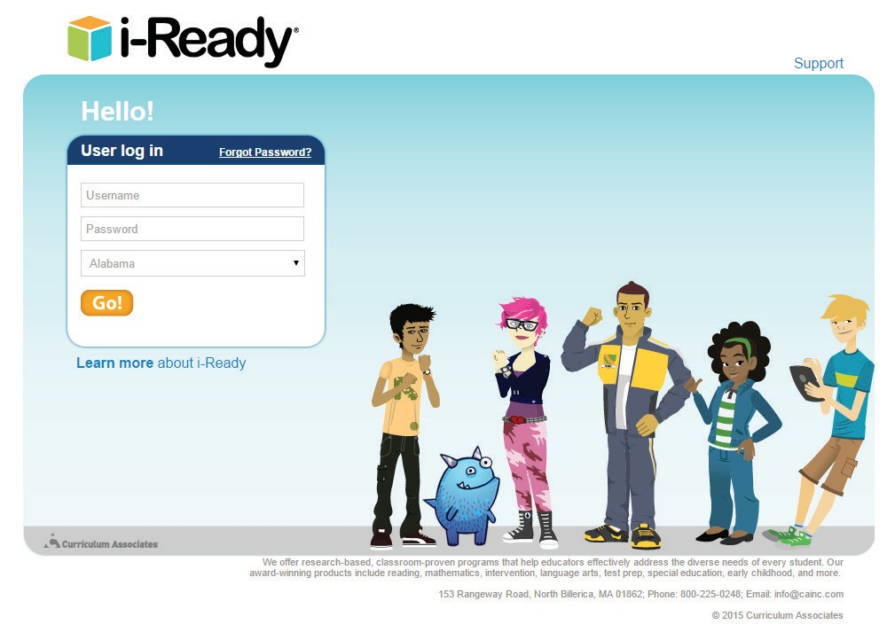Student Instructions for Completing Online Lessons

- Open an internet browser
(Internet Explorer, Firefox, Chrome or Safari).
- Go to login.i-ready.com
- Enter your Username and Password. If you do not have your Username and Password, ask your teacher.
- Select your state and click Go!

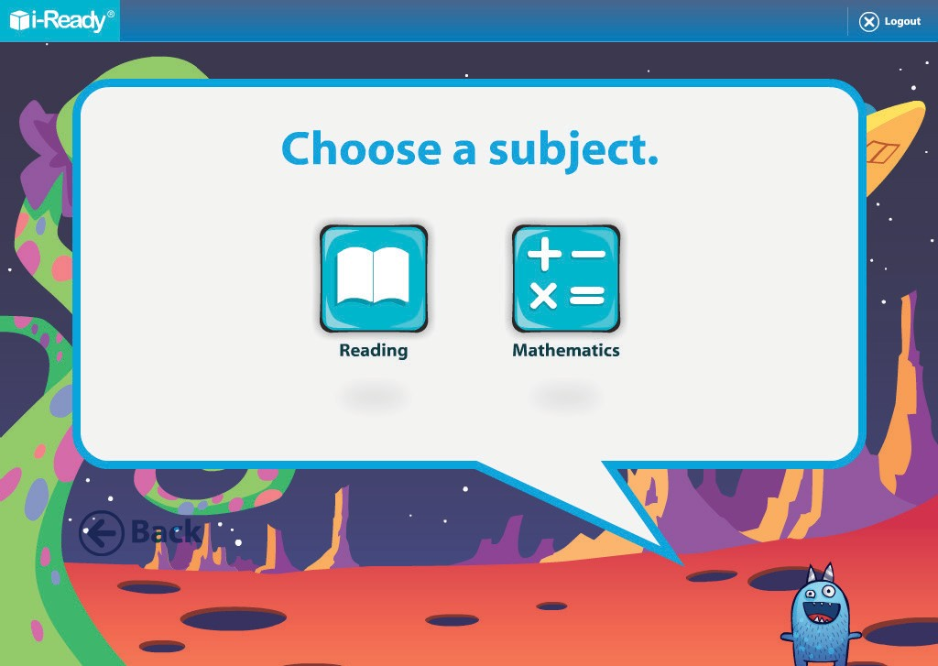

5. Select either Reading or Math. Your teacher will tell you which one to start with.

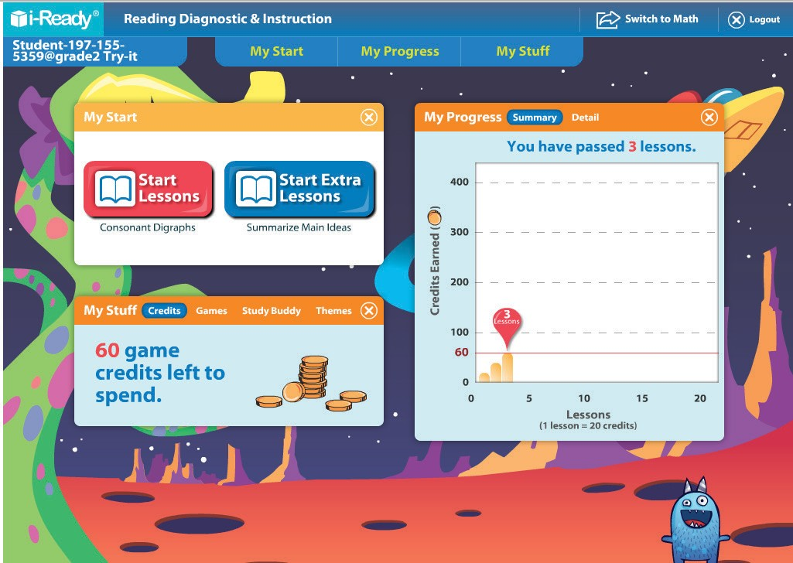
6. Keep track of your progress using the tabs
in the “My Progress” box.
7. Click on Start Lessons to begin next
assigned lesson.
8. Earn credits to play games with every
lesson you complete! Keep track of credits, select games, change Study Buddies, and change themes in the “My Stuff” box.

9. Have fun and do your best!

  - OF 3
©2015 Curriculum Associates, LLC

